**IBM Automation Assets**

1. Login to the OpenShift Console with the provided URL. Once logged in click **OperatorHub** under **Operators** menu.

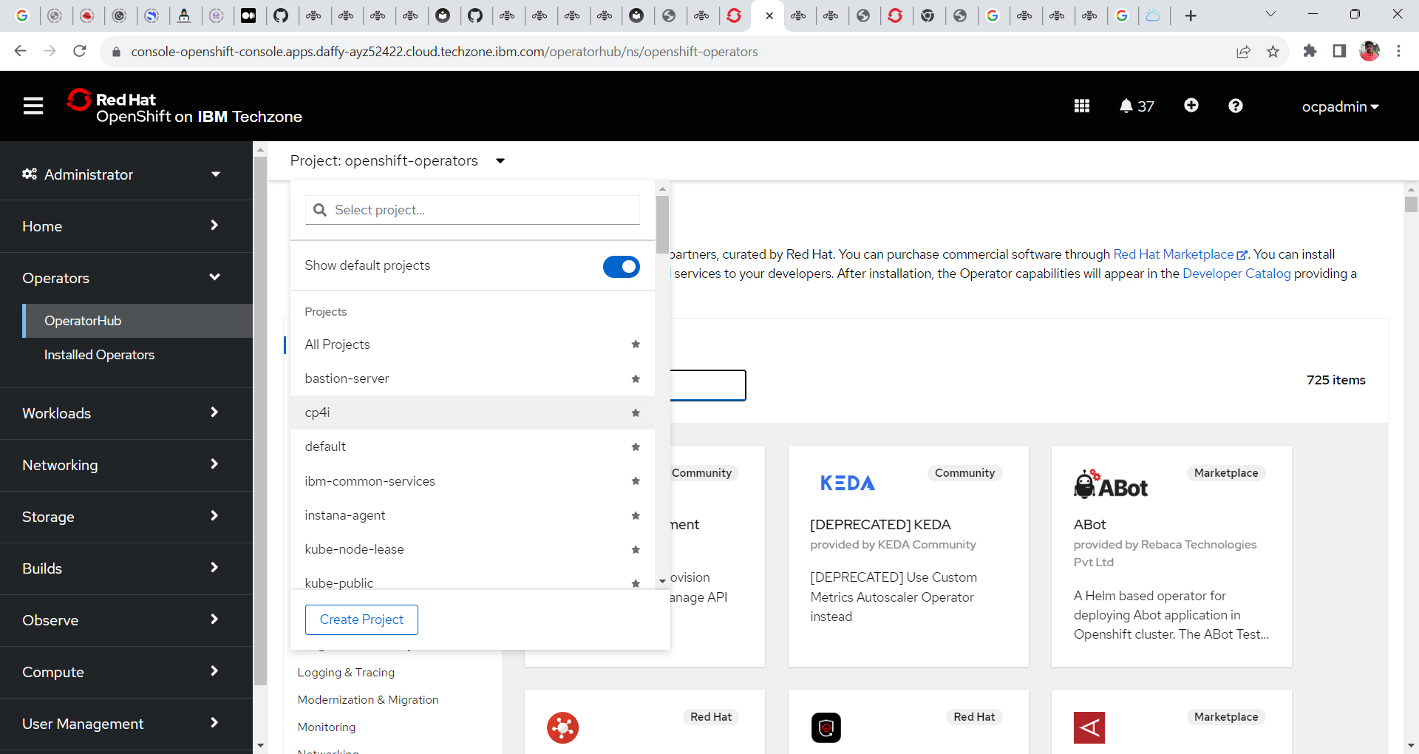

3. In the operator hub search for the tile **IBM Automation Foundation assets** and click on it.

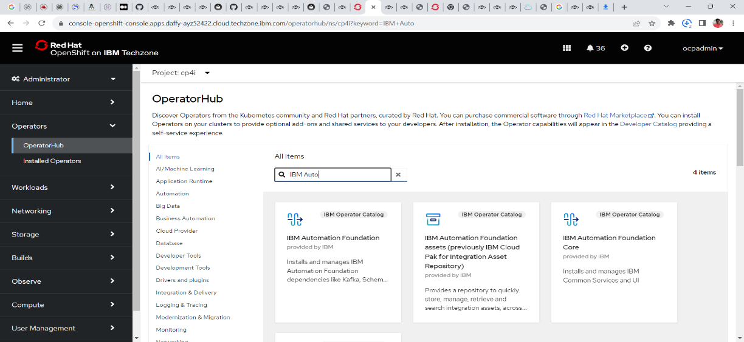

4. Read the document in the window and click on the **install** button.

5. In the following window select the following configs.

**Update Channel = 1.5**

**Installation Mode = All namespace on the cluster**

**Installed Namespace = openshift-operators**

**Update Approval = Automatic**

5. The Openshift Container Platform starts to install the operator. Wait for few minutes until the completion of the installation.

6. Once the IBM Automation Foundation assets operator is installed and ready to use click **view operator** to view the details of the Operator.